**DAILY ONLINE ACTIVITIES SUMMARY**

|  |  |  |  |  |  |  |  |
| --- | --- | --- | --- | --- | --- | --- | --- |
| **Date:** | **30/05/20** | | | | **Name:** | **Deena Muthsppa** | |
| **Sem & Sec** | **8th sem, A sec** | | | | **USN:** | **4AL16CS028** | |
| **Online Test Summary** | | | | | | | |
| **Subject** | | **No test was conducted** | | | | | |
| **Max. Marks** | |  | | **Score** | |  | |
| **Certification Course Summary** | | | | | | | |
| **Course** | **Python 3.7 Bootcamp|Beginner to intermediate level** | | | | | | |
| **Certificate Provider** | | | **Udemy** | **Duration** | | | **7.5 hrs** |
| **Coding Challenges** | | | | | | | |
| **Problem Statement: Find the number that is missing from the Array containing n distinct number taken from 0,1,2** | | | | | | | |
| **Status: Completed** | | | | | | | |
| **Uploaded the report in Github** | | | | **Yes** | | | |
| **If yes Repository name** | | | | **Deenamuthappa/Codig-Challenges** | | | |
| **Uploaded the report in slack** | | | | **Yes** | | | |

Online Test Details: Not conducted

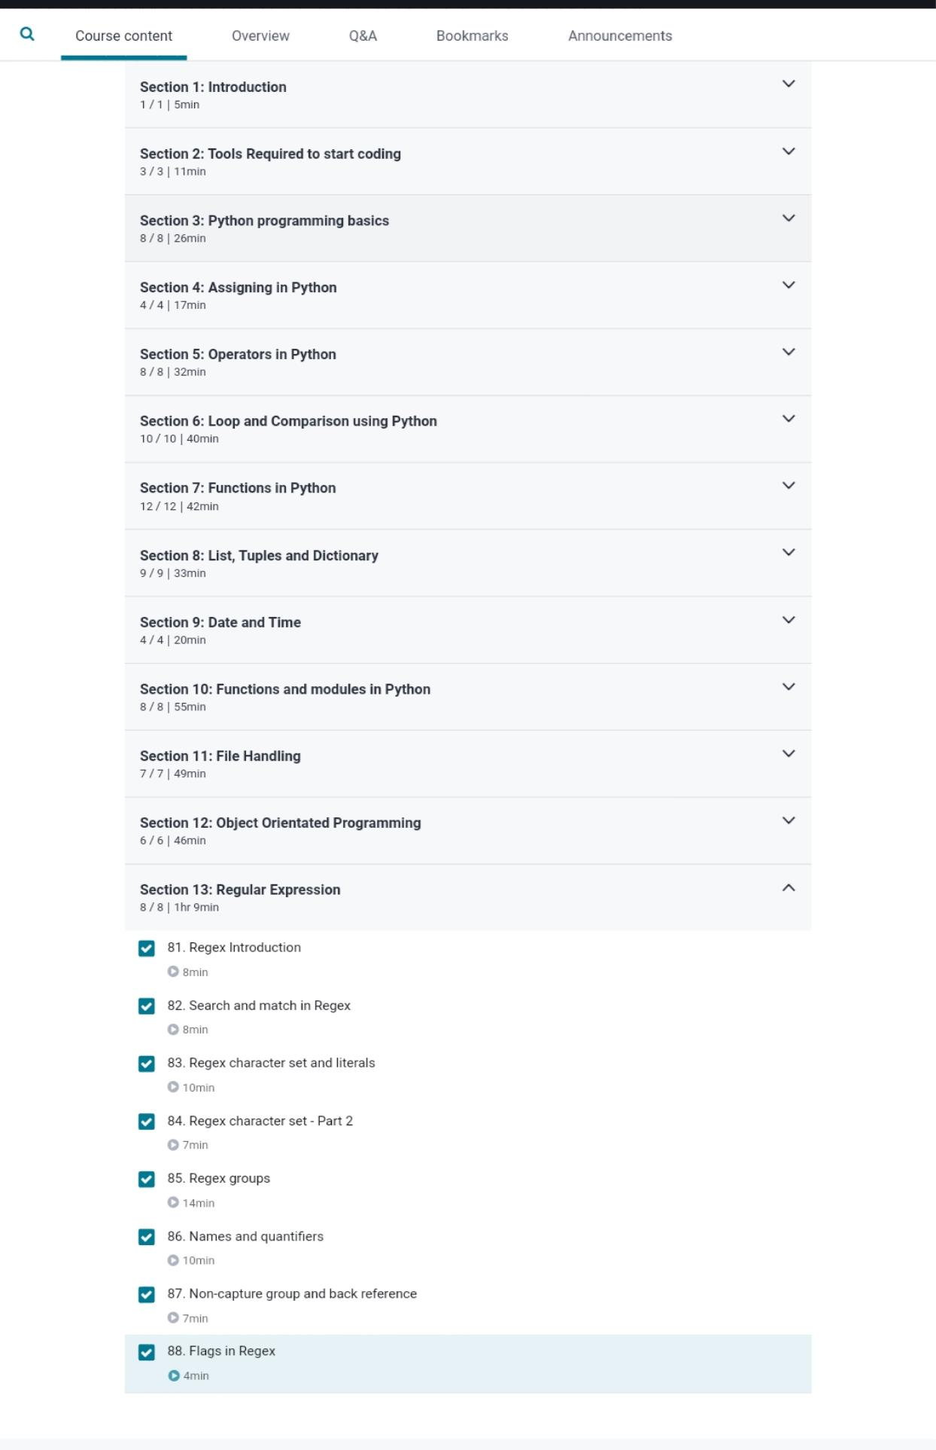Certification Course Details:



Coding Challenges Details:

1)

#include <stdio.h>  
int getMissingNo(int a[], int n)  
{  
int i, total;  
total = (n + 1) * (n + 2) / 2;  
for (i = 0; i < n; i++)  
total -= a[i];  
return total;  
}  
int main()  
{  
int a[] = { 1, 2, 4, 5, 6 };  
int miss = getMissingNo(a, 5);  
printf("%d", miss);  
getchar();  
}